CISC SIMULATOR

Manual

V 2.1

**Group 8**

Md Shahjalal

Tianyou Bao

Xuzheng Lu

Contents

1 Introduction 1

1.1 Debugging Panel 1

1.1.1 Register Indicators Area 1

1.1.2 Memory Area 2

1.1.3 Controller Area 2

1.2 Operation Panel (Console) 3

1.3 Classic Panel 4

1.4 Themes 4

2 Basic Operations 5

2.1 Writing Values to Registers 5

2.2 Writing Values to Memory 5

2.2.1 Using Memory Address Register and Memory Buffer Register 6

2.2.2 Modifying the Memory Area 6

2.3 Executing Instructions 7

2.3.1 Executing Instructions Step-by-Step 7

2.3.1 Executing Instructions Automatically 8

3 Executing Programs 10

3.1 Executing Program 1 10

3.1.1 Program Description 10

3.1.2 Running the Program 10

3.2 Executing Program 2 11

3.3 Executing a Custom Program Using IPL 11

3.3.1 Using Operation Panel (Console) 11

3.3.2 Using Debugging Panel 12

4 Instructions Reference 12

4.1 Load/Store Instructions 12

4.1.1 (01) LDR 12

4.1.2 (02) STR 12

4.1.3 (03) LDA 13

4.1.4 (41) LDX 13

4.1.5 (42) STX 13

4.2 Arithmetic and Logical Instructions 13

4.2.1 (04) AMR 14

4.2.2 (05) SMR 14

4.2.3 (06) AIR 14

4.2.4 (07) SIR 15

4.2.5 (20) MLT 15

4.2.6 (21) DVD 15

4.2.7 (22) TRR 15

4.2.8 (23) AND 16

4.2.9 (24) ORR 16

4.2.10 (25) NOT 16

4.3 Transfer Instructions 16

4.3.1 (10) JZ 17

4.3.2 (11) JNE 17

4.3.3 (12) JCC 17

4.3.4 (13) JMA 17

4.3.5 (14) JSR 18

4.3.6 (15) RFS 18

4.3.7 (16) SOB 18

4.3.8 (17) JGE 18

4.4 Shift/Rotate Instructions 19

4.4.1 (31) SRC 19

4.4.2 (32) RRC 19

4.5 I/O Instructions 19

4.5.1 (61) IN 20

4.5.2 (62) OUT 20

4.5.3 (63) CHK 20

4.6 Other Instructions 21

4.6.1 (00) HALT 21

# 1 Introduction

This simulator is a simulation of a Complex Instruction Set Computer (CISC). Three panels are designed for the simulator, and two themes are supported.

## 1.1 Debugging Panel

**Debugging Panel** displays all the information about the Registers, Indicators, and Memory in the computer and can be written manually.

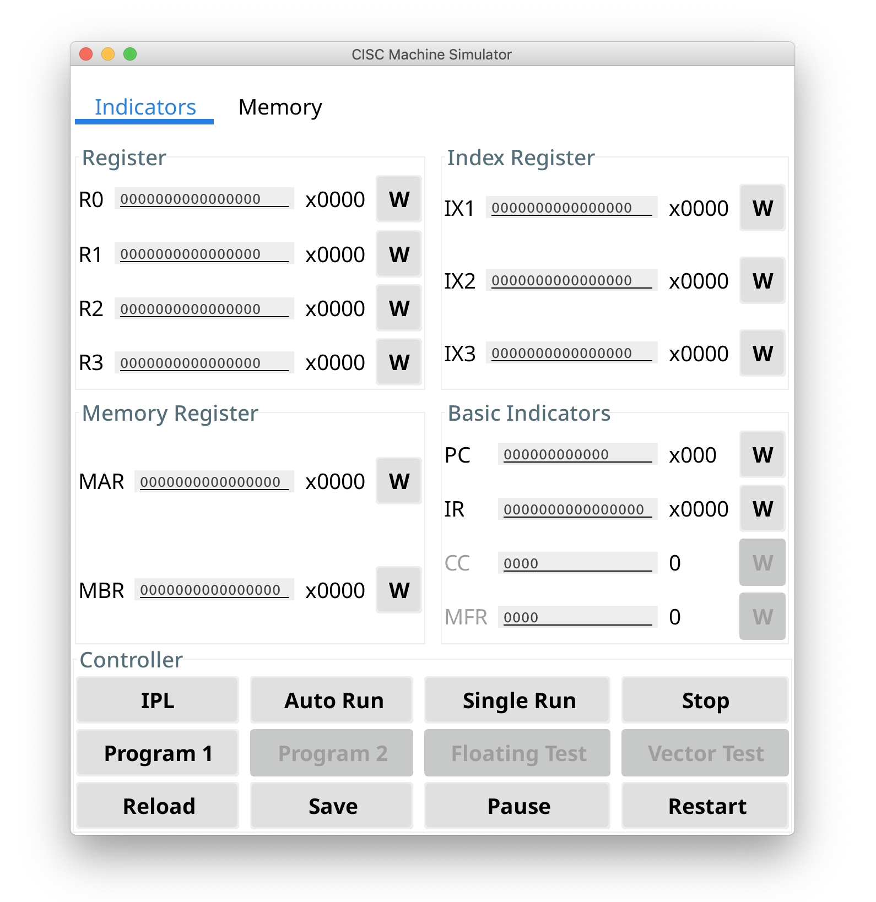

The panel is divided into three parts：

### 1.1.1 Register Indicators Area

#### 

The Register Indicators display the values of all kinds of registers.

* Click the ‘W’ button to manually modify the value of a register.
* Hexadecimal values are shown on the right.

|  |  |  |  |
| --- | --- | --- | --- |
| **Type** | **Size(bits)** | **Number** | **Description** |
| R0...R3 | 16 | 4 | General-Purpose Register |
| IX1...IX3 | 16 | 3 | Index Register |
| MAR | 16 | 1 | Memory Address Register |
| MBR | 16 | 1 | Memory Buffer Register |
| PC | 12 | 1 | Program Counter |
| IR | 16 | 1 | Instruction Register |
| CC | 4 | 1 | Condition Code |
| MFR | 4 | 1 | Machine Fault Register |

### 1.1.2 Memory Area

#### 

The Memory Area shows the address, the value, the Hexadecimal value, and the Assemble Code of each line on memory.

* The memory address pointed by the Program Counter will be highlighted.
* Double click to manually modify the binary value of a memory row.

### 1.1.3 Controller Area

The Controller Area integrates all function buttons and the instruction input box.

#### 

Functions of the buttons in Controller Area:

|  |  |
| --- | --- |
| **Button** | **Function** |
| IPL | Pre-load a program from I/O |
| Auto Run | Run the instructions until TRAP or HALT |
| Single Run | Run one instruction |
| Stop | Stop the workload on the machine |
| Program 1 | Run Program 1 |
| Reload | Reload the data from memory.txt to memory |
| Save | Save the data in memory to memory.txt |
| Pause | Pause the workload on the machine |
| Restart | Restart the machine |

## 1.2 Operation Panel (Console)

**Operation Panel** is a console used for system operation through the command line.

#### 

Commands supported:

|  |  |
| --- | --- |
| **Command** | **Description** |
| autorun | Run the instructions until TRAP or HALT (Same as ‘auto run’ and ‘run’) |
| auto run | Run the instructions Until TRAP or HALT (Same as ‘autorun’ and ‘run’) |
| clean | Clean the console (same as ‘cls’) |
| cls | Clean the console (same as ‘clean’) |
| exit | Shutdown the machine (same as ‘quit’ and ‘power off’) |
| floating test | Run the Floating Test |
| ipl | Load the program from I/O |
| pause | Pause the workload on the machine (not finished) |
| power off | Shutdown the machine (same as ‘exit’ and ‘quit’) |
| Program1 | Run Program 1 (same as ‘Program 1’) |
| Program 1 | Run Program 1 (same as ‘Program1’) |
| Program2 | Run Program 1 (same as ‘Program 2’) |
| Program 2 | Run Program 1 (same as ‘Program2’) |
| quit | Shutdown the machine (same as ‘exit’ and ‘power off’) |
| reload | Reload the data from memory.txt to memory |
| reset | Restart the machine (Same as ‘restart’) |
| restart | Restart the machine (Same as ‘reset’) |
| run | Run the instructions until TRAP or HALT (same as ‘autorun’ and ‘auto run’) |
| save | Save the data in memory to memory.txt |
| singlerun | Run one instruction (Same as ‘single run’) |
| single run | Run one instruction (Same as ‘singlerun’) |
| status | Show the status of the machine |
| stop | Stop the workload on the machine |
| switch theme | switch theme {$THEME_NAME} | Switch the theme of UI. Now support ‘Material Design Ocean’ (or ‘MaterialDesignOcean’) and ‘Material Design Lighter’ (or ‘MaterialDesignLighter’) |
| vector test | Run the Vector Test |
| /help | Show the command list |

## 1.3 Classic Panel

The appearance and operational logic of the **Classic Panel** emulate the PDP-8 computer. Users will use switches to input and lights for indication.

The **Classic Panel** has not been finished yet and will be released in the next version.

## 1.4 Themes

Two themes, Material Design Ocean and Material Design Lighter, are supported now. To change the theme, input ‘switch theme {$THEME_NAME}’ in **Operation Panel**.

**Material Design Lighter Theme (default)**

#### 

**Material Design Ocean Theme**

#### 

# 2 Basic Operations

## 2.1 Writing Values to Registers

Following the steps below to write a value to a register.

**Step 1**: Input a value into the box.

#### 

**Step 2**: Click the ‘W’ button at right to write the value to the register.

#### 

**Step 3**: Done! The value will be written to the Register.

**Error handling:**

- Input too long: Remove the excess bits from the left

- Input too short: Add zeros from the left

- Input is not binary: Pop up an Error window

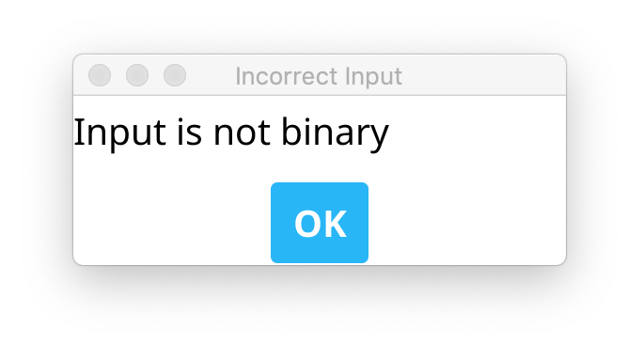

## 2.2 Writing Values to Memory

Two methods are acceptable to write a value to the Memory.

### 2.2.1 Using Memory Address Register and Memory Buffer Register

**Step 1**: Input a value into the MAR box.

#### 

**Step 2**: Click the ‘W’ button of MAR.

#### 

**Step 3**: Input a value into the MBR box.

#### 

**Step 4**: Click the ‘W’ button of MBR.

#### 

**Step 5**: Done! The value of MAR will be written to the Memory, and the MAR will automatically change to the next address.

#### 

#### 

### 2.2.2 Modifying the Memory Area

**Step 1**: Double click the memory row that needs to modify.

#### 

**Step 2**: An window as the following will pop up. Input the value to be written to the memory.

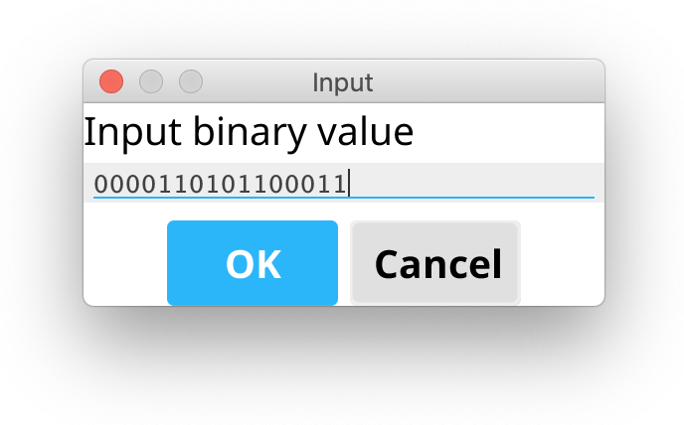

**Step 3**: Click the ‘OK’ button, and then the value will be written to the Memory.

#### 

## 2.3 Executing Instructions

Instruction can be executed step-by-step or automatically.

### 2.3.1 Executing Instructions Step-by-Step

**Step 1**: Store an instruction to the Memory.

#### 

**Step 2**: Write the address of the instruction to the Program Counter (PC).

#### 

**Step 3**: Click the ‘Single Run’ button, and then the instruction will be executed.

* The Program Counter will automatically point to the next address of Memory.
* The Instruction Register will store the last executed instruction.

#### 

#### 

### 2.3.1 Executing Instructions Automatically

**Step 1**: Store instructions to the Memory.

#### 

**Step 2**: Write the address of the **starting** instruction to the Program Counter (PC).

#### 

**Step 3**: Click the ‘Auto Run’ button, and then the instructions will be executed automatically.

* The Program Counter will automatically point to the next address of Memory after an instruction being executed.
* All the indicators will be continuously updated while the program is running.

#### 

#### 

#### 

**Step 4**: Click the ‘Pause’ button to pause the program or the ‘Stop’ button to stop the program.

# 3 Executing Programs

## 3.1 Executing Program 1

### 3.1.1 Program Description

Program 1 is a program that reads 20 numbers (integers) from the keyboard, prints the numbers to the console printer, requests a number from the user, and searches the 20 numbers read in for the number closest to the number entered by the user. The numbers distributed over the range of 0 … 65535. Print the number entered by the user and the number closest to that number.

### 3.1.2 Running the Program

**Step 1**: Input ‘program 1’ or ‘program1’ in the **Operation Panel (Console)** and then click the ‘Enter’ button. Or click the ‘Program 1’ button in the **Debugging Panel**.

#### 

#### 

**Step 2**: Input numbers (use comma to split numbers) and then click the ‘Enter’ button. You can fill the numbers several times to input the required 20 numbers.

#### 

**Step 3**: Input the number for comparing.

#### 

**Step 4**: Done! The result of the calculation will be output to the **Console**.

#### 

## 3.2 Executing Program 2

Not implemented yet.

## 3.3 Executing a Custom Program Using IPL

### 3.3.1 Using Operation Panel (Console)

**Step 1**: Write the custom program in a text file.

**Step 2**: Input ‘ipl’ command to the console to import the program to the memory.

**Step 4**: Input ‘auto run’ or ‘autorun’ command to the console, and then the program will be executed. Or input ‘single run’ or ‘singlerun’’ command to run the program step-by-step.

### 3.3.2 Using Debugging Panel

**Step 1**: Write the custom program in a text file.

**Step 2**: Click the ‘IPL’ button to import the program to the memory.

**Step 3**: Click the ‘Auto Run’ button, and then the program will be executed. Or click the ‘Single Run’ button to run the program step-by-step.

# 4 Instructions Reference

## 4.1 Load/Store Instructions

The instructions to load/store values from/to Registers or Memory. The binary instruction code format of Load/Store Instructions is as follows:

|  |  |  |  |  |
| --- | --- | --- | --- | --- |
| Opcode | R | IX | I | Address |
| 0 5 | 6 7 | 8 9 | 1  0 | 1 1  1 5 |

|  |  |  |
| --- | --- | --- |
| **Opcode:** | 6 bits | Specifies the instruction |
| **R:** | 2 bits | Specifies the General-Purpose Register |
| **IX:** | 2 bits | Specifies the Index Register |
| **I:** | 1 bit | Specifies Indirect Addressing  If I =1, indirect addressing; otherwise, no indirect addressing. |
| **Address:** | 5 bits | Specifies the location |

### 4.1.1 (01) LDR

|  |  |  |  |  |
| --- | --- | --- | --- | --- |
| 000001 | R | IX | I | Address |
| 0 5 | 6 7 | 8 9 | 1  0 | 1 1  1 5 |

|  |  |
| --- | --- |
| Instruction: | LDR r, x, address[, I] |
| Octal-Opcode: | 01 |
| Binary-Opcode: | 000001 |
| Function: | Loads Register from Memory |

### 4.1.2 (02) STR

|  |  |  |  |  |
| --- | --- | --- | --- | --- |
| 000010 | R | IX | I | Address |
| 0 5 | 6 7 | 8 9 | 1  0 | 1 1  1 5 |

|  |  |
| --- | --- |
| Instruction: | STR r, x, address[, I] |
| Octal-Opcode: | 02 |
| Binary-Opcode: | 000010 |
| Function: | Stores Register to Memory |

### 4.1.3 (03) LDA

|  |  |  |  |  |
| --- | --- | --- | --- | --- |
| 000011 | R | IX | I | Address |
| 0 5 | 6 7 | 8 9 | 1  0 | 1 1  1 5 |

|  |  |
| --- | --- |
| Instruction: | LDA r, x, address[, I] |
| Octal-Opcode: | 03 |
| Binary-Opcode: | 000011 |
| Function: | Loads Register with Address |

### 4.1.4 (41) LDX

|  |  |  |  |  |
| --- | --- | --- | --- | --- |
| 101001 | R | IX | I | Address |
| 0 5 | 6 7 | 8 9 | 1  0 | 1 1  1 5 |

|  |  |
| --- | --- |
| Instruction: | LDX x, address[, I] |
| Octal-Opcode: | 41 |
| Binary-Opcode: | 101001 |
| Function: | Loads Index Register from Memory |

### 4.1.5 (42) STX

|  |  |  |  |  |
| --- | --- | --- | --- | --- |
| 101010 | R | IX | I | Address |
| 0 5 | 6 7 | 8 9 | 1  0 | 1 1  1 5 |

|  |  |
| --- | --- |
| Instruction: | STX x, address[, I] |
| Octal-Opcode: | 42 |
| Binary-Opcode: | 101010 |
| Function: | Stores Index Register to Memory |

## 4.2 Arithmetic and Logical Instructions

The instructions to perform most of the computational works in the machine.

The binary instruction code format of basic Arithmetic and Logical Instructions is as follows:

|  |  |  |  |  |
| --- | --- | --- | --- | --- |
| Opcode | R | IX | I | Address |
| 0 5 | 6 7 | 8 9 | 1  0 | 1 1  1 5 |

|  |  |  |
| --- | --- | --- |
| **Opcode:** | 6 bits | Specifies the instruction |
| **R:** | 2 bits | Specifies the General-Purpose Register |
| **IX:** | 2 bits | Specifies the Index Register |
| **I:** | 1 bit | Specifies Indirect Addressing  If I =1, indirect addressing; otherwise, no indirect addressing. |
| **Address:** | 5 bits | Specifies the location |

The binary instruction code format of register-to-register Arithmetic and Logical Instructions is as follows:

|  |  |  |  |
| --- | --- | --- | --- |
| Opcode | Rx | Ry |  |
| 0 5 | 6 7 | 8 9 | 1 1  0 5 |

|  |  |  |
| --- | --- | --- |
| **Opcode:** | 6 bits | Specifies the instruction |
| **Rx:** | 2 bits | Specifies the General-Purpose Register x |
| **Ry:** | 2 bits | Specifies the General-Purpose Register y |

### 4.2.1 (04) AMR

|  |  |  |  |  |
| --- | --- | --- | --- | --- |
| 000100 | R | IX | I | Address |
| 0 5 | 6 7 | 8 9 | 1  0 | 1 1  1 5 |

|  |  |
| --- | --- |
| Instruction: | AMR r, x, address[, I] |
| Octal-Opcode: | 04 |
| Binary-Opcode: | 000100 |
| Function: | Add Memory to Register |

### 4.2.2 (05) SMR

|  |  |  |  |  |
| --- | --- | --- | --- | --- |
| 000101 | R | IX | I | Address |
| 0 5 | 6 7 | 8 9 | 1  0 | 1 1  1 5 |

|  |  |
| --- | --- |
| Instruction: | SMR r, x, address[, I] |
| Octal-Opcode: | 05 |
| Binary-Opcode: | 000101 |
| Function: | Subtract Memory from Register |

### 4.2.3 (06) AIR

|  |  |  |  |  |
| --- | --- | --- | --- | --- |
| 000110 | R |  |  | Address |
| 0 5 | 6 7 | 8 9 | 1  0 | 1 1  1 5 |

|  |  |
| --- | --- |
| Instruction: | AIR r, immed |
| Octal-Opcode: | 06 |
| Binary-Opcode: | 000110 |
| Function: | Add Immediate to Register |

### 4.2.4 (07) SIR

|  |  |  |  |  |
| --- | --- | --- | --- | --- |
| 000111 | R |  |  | Address |
| 0 5 | 6 7 | 8 9 | 1  0 | 1 1  1 5 |

|  |  |
| --- | --- |
| Instruction: | SIR r, immed |
| Octal-Opcode: | 07 |
| Binary-Opcode: | 000111 |
| Function: | Subtract Immediate from Register |

### 4.2.5 (20) MLT

|  |  |  |  |
| --- | --- | --- | --- |
| 010100 | Rx | Ry |  |
| 0 5 | 6 7 | 8 9 | 1 1  0 5 |

|  |  |
| --- | --- |
| Instruction: | MLT rx, ry |
| Octal-Opcode: | 20 |
| Binary-Opcode: | 010100 |
| Function: | Multiply Register by Register |

### 4.2.6 (21) DVD

|  |  |  |  |
| --- | --- | --- | --- |
| 010101 | Rx | Ry |  |
| 0 5 | 6 7 | 8 9 | 1 1  0 5 |

|  |  |
| --- | --- |
| Instruction: | DVD rx, ry |
| Octal-Opcode: | 21 |
| Binary-Opcode: | 010101 |
| Function: | Divide Register by Register |

### 4.2.7 (22) TRR

|  |  |  |  |
| --- | --- | --- | --- |
| 010110 | Rx | Ry |  |
| 0 5 | 6 7 | 8 9 | 1 1  0 5 |

|  |  |
| --- | --- |
| Instruction: | TRR rx, ry |
| Octal-Opcode: | 22 |
| Binary-Opcode: | 010110 |
| Function: | Test the Equality of Register and Register |

### 4.2.8 (23) AND

|  |  |  |  |
| --- | --- | --- | --- |
| 010111 | Rx | Ry |  |
| 0 5 | 6 7 | 8 9 | 1 1  0 5 |

|  |  |
| --- | --- |
| Instruction: | AND rx, ry |
| Octal-Opcode: | 23 |
| Binary-Opcode: | 010111 |
| Function: | Logical AND of Register and Register |

### 4.2.9 (24) ORR

|  |  |  |  |
| --- | --- | --- | --- |
| 011000 | Rx | Ry |  |
| 0 5 | 6 7 | 8 9 | 1 1  0 5 |

|  |  |
| --- | --- |
| Instruction: | ORR rx, ry |
| Octal-Opcode: | 24 |
| Binary-Opcode: | 011000 |
| Function: | Logical OR of Register and Register |

### 4.2.10 (25) NOT

|  |  |  |
| --- | --- | --- |
| 011001 | Rx |  |
| 0 5 | 6 7 | 8 1  5 |

|  |  |
| --- | --- |
| Instruction: | NOT rx |
| Octal-Opcode: | 25 |
| Binary-Opcode: | 011001 |
| Function: | Logical NOT of Register to Register |

## 4.3 Transfer Instructions

The instructions to check the value of a register and then change the control of program execution.

The binary instruction code format of Transfer Instructions is as follows:

|  |  |  |  |  |
| --- | --- | --- | --- | --- |
| Opcode | R | IX | I | Address |
| 0 5 | 6 7 | 8 9 | 1  0 | 1 1  1 5 |

|  |  |  |
| --- | --- | --- |
| **Opcode:** | 6 bits | Specifies the instruction |
| **R:** | 2 bits | Specifies the General-Purpose Register |
| **IX:** | 2 bits | Specifies the Index Register |
| **I:** | 1 bit | Specifies Indirect Addressing  If I =1, indirect addressing; otherwise, no indirect addressing. |
| **Address:** | 5 bits | Specifies the location |

### 4.3.1 (10) JZ

|  |  |  |  |  |
| --- | --- | --- | --- | --- |
| 001010 | R | IX | I | Address |
| 0 5 | 6 7 | 8 9 | 1  0 | 1 1  1 5 |

|  |  |
| --- | --- |
| Instruction: | JZ r, x, address[, I] |
| Octal-Opcode: | 10 |
| Binary-Opcode: | 001010 |
| Function: | Jump if Zero |

### 4.3.2 (11) JNE

|  |  |  |  |  |
| --- | --- | --- | --- | --- |
| 001011 | R | IX | I | Address |
| 0 5 | 6 7 | 8 9 | 1  0 | 1 1  1 5 |

|  |  |
| --- | --- |
| Instruction: | JNE r, x, address[, I] |
| Octal-Opcode: | 11 |
| Binary-Opcode: | 001011 |
| Function: | Jump if Not Equal |

### 4.3.3 (12) JCC

|  |  |  |  |  |
| --- | --- | --- | --- | --- |
| 001100 | R | IX | I | Address |
| 0 5 | 6 7 | 8 9 | 1  0 | 1 1  1 5 |

|  |  |
| --- | --- |
| Instruction: | JCC cc, x, address[, I] |
| Octal-Opcode: | 12 |
| Binary-Opcode: | 001100 |
| Function: | Jump if Condition Code |

### 4.3.4 (13) JMA

|  |  |  |  |  |
| --- | --- | --- | --- | --- |
| 001101 | R | IX | I | Address |
| 0 5 | 6 7 | 8 9 | 1  0 | 1 1  1 5 |

|  |  |
| --- | --- |
| Instruction: | JMA x, address[, I] |
| Octal-Opcode: | 13 |
| Binary-Opcode: | 001101 |
| Function: | Unconditional Jump to Address |

### 4.3.5 (14) JSR

|  |  |  |  |  |
| --- | --- | --- | --- | --- |
| 001110 | R | IX | I | Address |
| 0 5 | 6 7 | 8 9 | 1  0 | 1 1  1 5 |

|  |  |
| --- | --- |
| Instruction: | JSR x, address[, I] |
| Octal-Opcode: | 14 |
| Binary-Opcode: | 001110 |
| Function: | Jump and Save Return Address |

### 4.3.6 (15) RFS

|  |  |  |  |  |
| --- | --- | --- | --- | --- |
| 001111 |  |  |  | Immed |
| 0 5 | 6 7 | 8 9 | 1  0 | 1 1  1 5 |

|  |  |
| --- | --- |
| Instruction: | RFS immed |
| Octal-Opcode: | 15 |
| Binary-Opcode: | 001111 |
| Function: | Return from Subroutine with Return Code as Immediate Portion (optional) Stored in the Instruction’s Address Field |

### 4.3.7 (16) SOB

|  |  |  |  |  |
| --- | --- | --- | --- | --- |
| 010000 | R | IX | I | Address |
| 0 5 | 6 7 | 8 9 | 1  0 | 1 1  1 5 |

|  |  |
| --- | --- |
| Instruction: | SOB r, x, address[, I] |
| Octal-Opcode: | 16 |
| Binary-Opcode: | 010000 |
| Function: | Subtract One and Branch |

### 4.3.8 (17) JGE

|  |  |  |  |  |
| --- | --- | --- | --- | --- |
| 010001 | R | IX | I | Address |
| 0 5 | 6 7 | 8 9 | 1  0 | 1 1  1 5 |

|  |  |
| --- | --- |
| Instruction: | JGE r, x, address[, I] |
| Octal-Opcode: | 17 |
| Binary-Opcode: | 010001 |
| Function: | Jump Greater than or Equal to |

## 4.4 Shift/Rotate Instructions

The instructions to manipulate a datum in a register. The binary instruction code format of Shift and Rotate Instructions is as follows:

|  |  |  |  |  |  |
| --- | --- | --- | --- | --- | --- |
| Opcode | R | A/L | L/R |  | Count |
| 0 5 | 6 7 | 8 | 9 | 1 1  0 1 | 1 1  2 5 |

|  |  |  |
| --- | --- | --- |
| **Opcode:** | 6 bits | Specifies the instruction |
| **R:** | 2 bits | Specifies the General-Purpose Register |
| **A/L:** | 2 bits | Arithmetic Shift (A/L = 0); Logical Shift (A/L = 1) |
| **L/R:** | 2 bits | Logical Rotate (L/R = 1) |
| **Count:** | 4 bits | Specifies the Count for Operation |

### 4.4.1 (31) SRC

|  |  |  |  |  |  |
| --- | --- | --- | --- | --- | --- |
| Opcode | R | A/L | L/R |  | Count |
| 0 5 | 6 7 | 8 | 9 | 1 1  0 1 | 1 1  2 5 |

|  |  |
| --- | --- |
| Instruction: | SRC r, count, L/R, A/L |
| Octal-Opcode: | 31 |
| Binary-Opcode: | 011111 |
| Function: | Shift Register by Count |

### 4.4.2 (32) RRC

|  |  |  |  |  |  |
| --- | --- | --- | --- | --- | --- |
| Opcode | R | A/L | L/R |  | Count |
| 0 5 | 6 7 | 8 | 9 | 1 1  0 1 | 1 1  2 5 |

|  |  |
| --- | --- |
| Instruction: | RRC r, count, L/R, A/L |
| Octal-Opcode: | 32 |
| Binary-Opcode: | 100000 |
| Function: | Rotate Register by Count |

## 4.5 I/O Instructions

The instructions to communicate with the peripherals attached to the computer system. The binary instruction code format of I/O Instructions is as follows:

|  |  |  |  |
| --- | --- | --- | --- |
| Opcode | R |  | DevID |
| 0 5 | 6 7 | 81  0 | 1 1  1 5 |

|  |  |  |
| --- | --- | --- |
| **Opcode:** | 6 bits | Specifies the instruction |
| **R:** | 2 bits | Specifies the General-Purpose Register |
| **DevID:** | 5 bits | Device ID:  0 Console Keyboard  1 Console Printer  2 Card Reader  3-31 Console Registers, Switches, etc. |

### 4.5.1 (61) IN

|  |  |  |  |
| --- | --- | --- | --- |
| 111101 | R |  | DevID |
| 0 5 | 6 7 | 81  0 | 1 1  1 5 |

|  |  |
| --- | --- |
| Instruction: | IN r, devid |
| Octal-Opcode: | 61 |
| Binary-Opcode: | 111101 |
| Function: | Input Character to Register from Device |

### 4.5.2 (62) OUT

|  |  |  |  |
| --- | --- | --- | --- |
| 111110 | R |  | DevID |
| 0 5 | 6 7 | 81  0 | 1 1  1 5 |

|  |  |
| --- | --- |
| Instruction: | OUT r, devid |
| Octal-Opcode: | 62 |
| Binary-Opcode: | 111110 |
| Function: | Output Character to Device from Register |

### 4.5.3 (63) CHK

|  |  |  |  |
| --- | --- | --- | --- |
| 111111 | R |  | DevID |
| 0 5 | 6 7 | 81  0 | 1 1  1 5 |

|  |  |
| --- | --- |
| Instruction: | CHK r, devid |
| Octal-Opcode: | 63 |
| Binary-Opcode: | 111111 |
| Function: | Check Device Status to Register |

## 4.6 Other Instructions

### 4.6.1 (00) HALT

|  |  |
| --- | --- |
| 000000 |  |
| 0 5 | 6 1  5 |

|  |  |
| --- | --- |
| Instruction: | HALT |
| Octal-Opcode: | 00 |
| Binary-Opcode: | 000000 |
| Function: | Stop the machine |